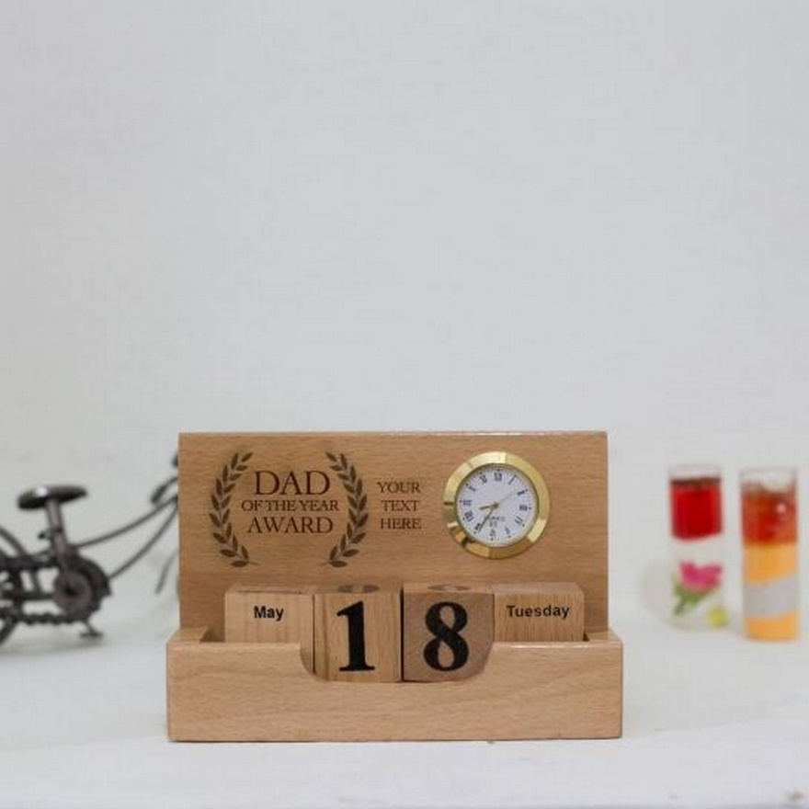WOODEN TABLE CALENDAR  
RYANA CALENDARS is selling wonderful CALENDARS! at reasonable prices. It has perfect designs and color combinations.

RS 1550